**Noted,**

**I will proceed.**

**From:** Charles Akoury   
**Sent:** 21 April 2015 18:30  
**To:** Mirza Asgar; Faisal Usman; Mohammed Abdul Imran; Ibrahem AL-Safadi  
**Cc:** Hassan Alkhatib; Roger Chamoun; Basim Ghandour; Steve Cotter  
**Subject:** RE: WMS always showing Error message

Dear Mirza,

Please open a case and attach the screen shot with the case or provide the file as attachements

Best Regards,  
  
   
**Charles A. Akoury**IT Manager

Tel: +966 12 2288922  
Tahlia Street - Elite Center

Tel: +966 12 6080680   
Fax: +966 12 6080033  
  
PO BOX 42404 Jeddah 21541 Saudi Arabia   
e-mail: [cakoury@arrow-food.com](https://mail.arrow-food.com/owa/redir.aspx?C=02683912d09d43c389bd8832e20e1cfa&URL=mailto%3acakoury%40arrow-food.com)

P.O.Box: 5981 Jeddah 21432 KSA

*The information contained and transmitted with this e-mail message is PRIVILEGED AND/OR CONFIDENTIAL. It is intended only for the individual or entity designated above. If you are not the named recipient of this e-mail message or have otherwise received this e-mail message in error, please delete the message immediately and notify the sender. E-mail transmission cannot be guaranteed to be secure or error free as information could be intercepted, corrupted, lost, destroyed, arrive late or incomplete, or contain viruses. The sender therefore is in no way liable for any errors or omissions in the content of this message, which may arise as a result of e-mail transmission. Opinions, conclusions and other information in this message that do not relate to the official business of my firm shall be understood as neither given nor endorsed by it.*

**From:** Mirza Asgar  
**Sent:** Tuesday, April 21, 2015 6:25 PM  
**To:** Faisal Usman; Charles Akoury; Mohammed Abdul Imran; Ibrahem AL-Safadi  
**Cc:** Hassan Alkhatib; Roger Chamoun; Basim Ghandour; Steve Cotter  
**Subject:** RE: WMS always showing Error message



**Dear Mr. Charles,**

**Please find the attached mail witch I send to sns its showing always error as below when I do allocated also. Kindly check his reply pls.**

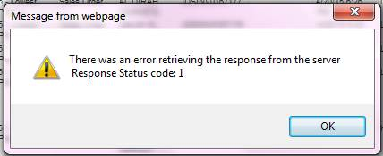

**From:** Faisal Usman   
**Sent:** 21 April 2015 18:20  
**To:** Charles Akoury; Mohammed Abdul Imran; Ibrahem AL-Safadi  
**Cc:** Hassan Alkhatib; Roger Chamoun; Basim Ghandour; Steve Cotter; Mirza Asgar  
**Subject:** WMS always showing Error message

Dear All,

     WMS showing always error message every single entry..Please check…

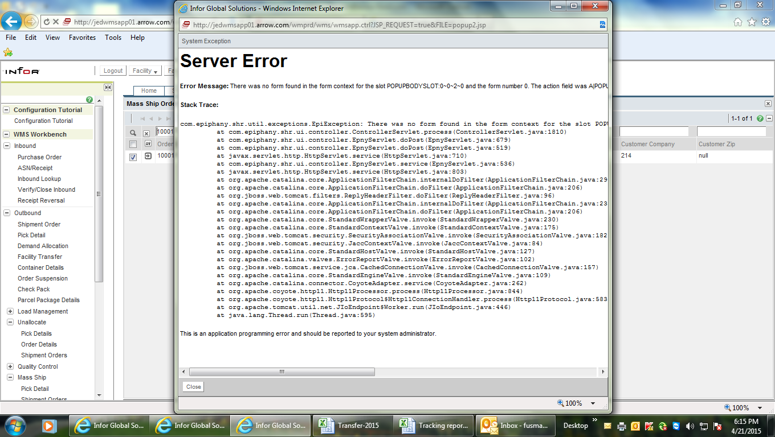

With Warm Regards

**Faisal**

Wms super user

   Jeddah-Beraiman

cid:image004.jpg@01D07C61.7A394570 Think of the environmental impact before printing this Page